**Code Challenge Implementation Description**

|  |
| --- |
| **Tech Stack** |
| Java 13 |
| Springboot 2.5.5 |
| Microservice Architecture |
| Backend For Front End Pattern |
| Spring Data JPA |
| H2 In Memory Database |
| Lombok, Maven,MockMvc |

**Components Description**

|  |  |  |
| --- | --- | --- |
| **Component** | **Type** | **Functionality** |
| contmgmt-web-bff | Microservice | Controller, Configuration, Properties, Swagger |
| contmgmt-service-boot | Microservice | Controller, Service, Respository, Configuration, DB Properties, Swagger, Test cases |
| contmgmt-service-api | Dependency | Request, Response, FeignClient, Interfaces |
| base-service-common | Dependency | Secutiry Filter, Interceptor, Exception, Advice, Feign Interceptor |
| jsonplaceholder-service-api | Dependency | JSON Placeholder APIs Implementation, PropertiesConfigurations, RestTemplate Configuration, Rerty implementation |

**Components Linking**

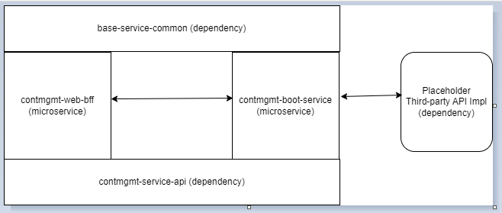

**High Level Design**

